**PROJECT DOCUMENTATION**

**“Personal Technical Portfolio Documentation”**

**TEAM:**

* Team ID: LTVIP2023TMID08019
* Team Size: 4
* Team Leader: Jami Prasanna Sai Manasa
* Team members: Korupala Srima

N. Anita

Kotni . Lavanya

**INTRODUCTION:**

**Project Overview:**

The Personal Technical Portfolio is a static web application designed to showcase an individual's technical skills, projects, achievements, and experience in a visually appealing and organized manner. It aims to highlight their expertise, demonstrate their coding abilities, and provide a comprehensive understanding of their technical background to potential employers, clients, or collaborators. The goal of this application is to create a visually compelling and professional portfolio that impresses visitors and establishes a strong online presence.

**Technology used:**

* **HTML**
* **CSS**
* **JAVASCRIPT(LITTLE)**

**STRUCTURE OF THE PROJECT:**

* At first we created a new project folder for the Personal Technical Portfolio Website.
* Inside the project folder, we created the following files/folders:
* Index.html
* Style.css
* Images
* And our own html and css styles

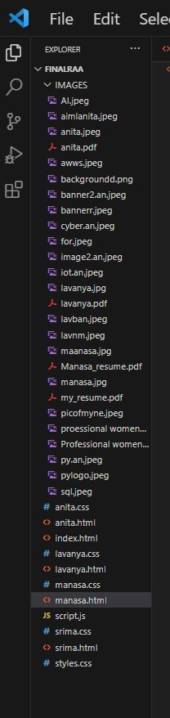

**DESIGN AND IMPLEMENTATION:**

It involves several steps to create an attractive and functional webpage:

**1.The user interface of html:**

* First we started by sketching a rough wireframe of our webpage's layout.,and planned where different elements like header, navigation, content sections, and footer will be placed.
* **HTML Structure:** Created the basic structure of our webpage using HTML. Begin with the **<!DOCTYPE html>** declaration, **<html>** element, and included essential metadata within **the <head> section.**
* **Title and Meta Tags**: Set the title of your webpage using the **<title>** tag within the **<head> section**. Add relevant meta tags for character encoding, viewport settings, and other metadata.
* **Header Section:** Designed and implemented the header section, including the website logo, navigation menu, and introductory text. Used **<header>** and appropriate semantic tags.
* **Banner**: We designed a banner that captures attention and introduces the website's purpose or main content. Used images, text, and a combination**.**
* **Content Sections:** Created the main content sections of the webpage, such as project showcases, about me, skills, achievements. Used semantic HTML elements like <section> for each content block.

**2.Styling of the webpage Using CSS:**

* Decided the overall look and feel of our webpage. Considered color schemes, typography choices, and the overall design aesthetic.
* **Create a Stylesheet**: We Set up a separate CSS file to maintain organized styling. And linked this file to our HTML document using the **<link>** tag within the **<head>** section.
* **Normalize Styles**: Begin with a CSS normalization to ensure consistent default styles across different browsers. This helps avoid inconsistencies in rendering.
* **Layout and Structure**: Defined the layout structure by styling container elements like **<header>, <main>, <section>, <article>, <nav>, and <footer>.** Used properties like width, margin, padding, and display to create the desired layout.
* **Typography**: Setting the font family, size, line height, and color for text using properties like font-family, font-size, line-height, and color. By ensuring readability and consistency.
* **Colors and Backgrounds**: Defined color schemes for elements using properties like background-color and color. And also set background images using background-image.
* **Styling Elements**: Styled various HTML elements using CSS selectors. Applied styles to headings, paragraphs, links, lists, buttons, and input fields to create a consistent and visually pleasing appearance.
* **Borders and Box Shadows**: Used border properties to add borders to elements.
* **Spacing and Alignment**: Used properties like margin and padding to control spacing between elements, text-align and vertical-align to control alignment.
* **Responsive Design**: Implemented media queries to adjust styles based on different screen sizes. This ensures your webpage looks good on various devices.
* We have also used a touch of javascript for the purpose of to make our portfolio a responsive and to look good.
* **Live Server:**

After wirting the code for every section we used to see the result of that particular section using the live server in the VS CODE ,which helped us a lot to improve our styling in a better way.

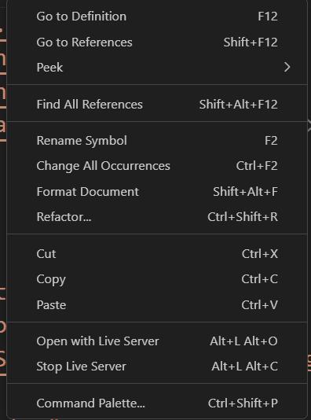

**PROJECT DESCRIPTION:**

**Personal Portfolio Documentation**

The project involves creating a comprehensive documentation for a personal portfolio, showcasing my skills and accomplishments as a front-end developer. The documentation will provide detailed insights into the projects I've undertaken, the technologies utilized, and the design decisions made. It will highlight my proficiency in HTML, CSS, and JavaScript, as well as demonstrate my ability to create responsive and visually appealing web experiences. The documentation will also outline my development process, problem-solving strategies, and the growth I've achieved through this journey. Ultimately, this project aims to present a clear and informative representation of my expertise to potential employers, clients, and fellow developers.

**Technologies Used:**

**HTML:**

* Hypertext Markup Language is the foundational language of the web, used to structure and present content on webpages.
* It employs a system of tags and elements to define the hierarchy and semantics of various types of content, such as text, images, links, headings, and forms.
* HTML's role is to provide the structure and foundation for web documents, enabling browsers to render content in a meaningful and organized manner. It forms the backbone upon which CSS (Cascading Style Sheets) and JavaScript interact, creating interactive and visually appealing websites.

**CSS:**

* Cascading Style Sheets is a crucial language for web design, allowing developers to control the visual appearance and layout of HTML elements.
* It defines how content is presented, including aspects like colours, fonts, spacing, and positioning. By separating the presentation layer from the content layer, CSS enables consistent and cohesive styling across multiple web pages.
* Its cascading nature means styles can be inherited, overridden, or combined, providing flexibility and efficiency. CSS plays a vital role in creating visually appealing, responsive, and user-friendly websites that enhance the overall user experience.

JAVASCRIPT:

* JavaScript is a dynamic scripting language that adds interactivity and functionality to web pages and create responsive elements.

**CODE SAMPLES:**

**HTML**

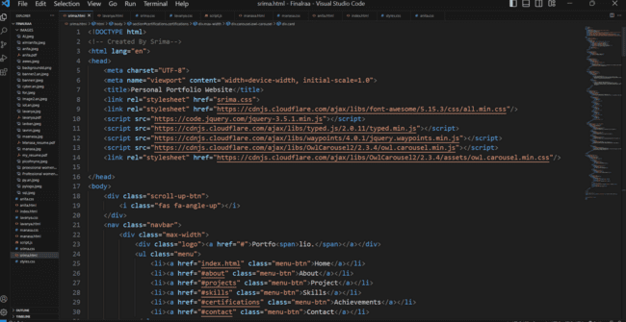

**MAIN PAGE:**

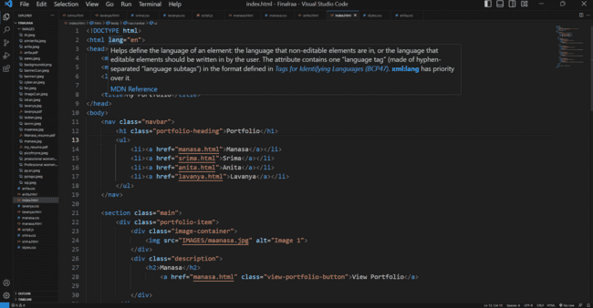

**CSS**

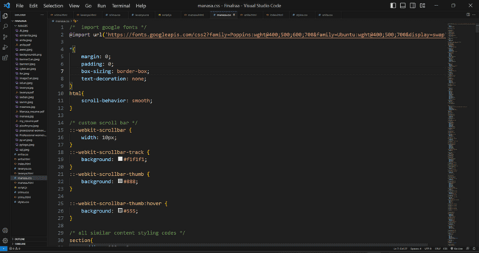

**MAIN STYLE PAGE:**

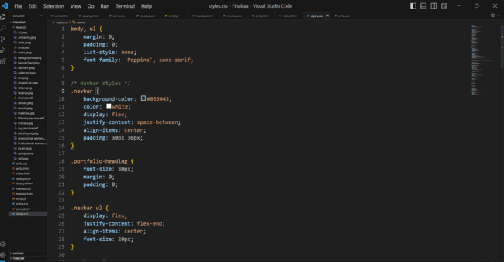**JAVASCRIPT:**

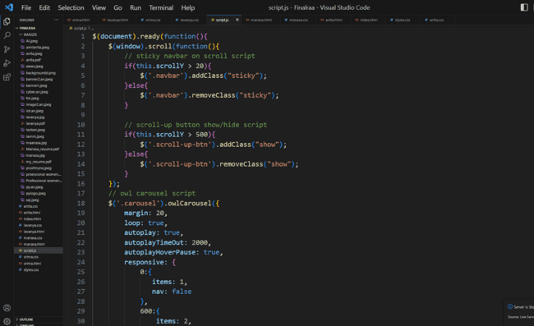

**RESULT:**

**MAIN PAGE**

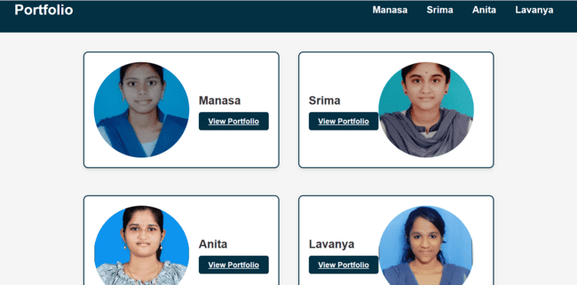

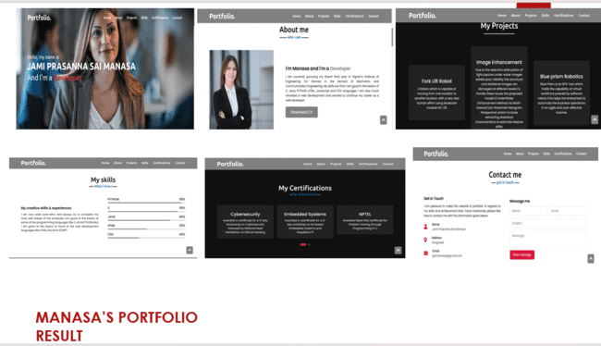

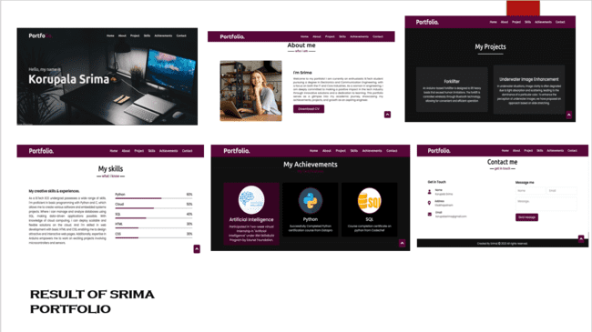

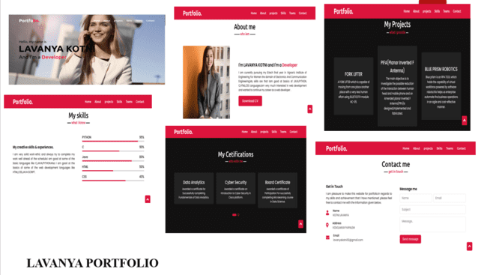

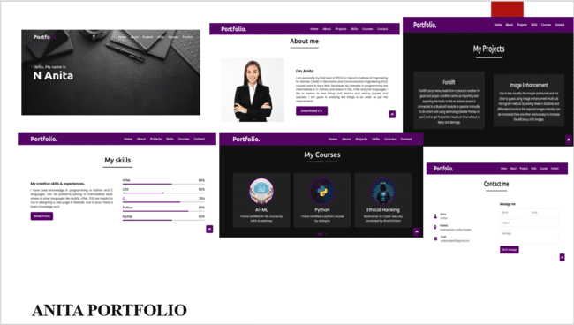

**PURPOSE OF THE PORTFOLIO:**

* The purpose of a personal technical portfolio is to showcase and highlight your skills, expertise, and achievements in the field of technology. It serves as a visual and interactive representation of your capabilities, projects, and growth. By presenting your work, design sensibilities, and coding proficiency, the portfolio enhances your professional image, making it a powerful tool for attracting job opportunities, networking, and establishing credibility within the tech industry.

**WHO ARE THE END USERS:**

* **Recruiters & Educators:**For Recruiters: Recruiters use personal technical portfolios to evaluate candidates' expertise, project experience, and coding abilities. It provides them with a clear overview of a candidate's suitability for a role and helps in making informed hiring decisions.
* **Students :** A personal technical portfolio is used by students to showcase their skills, projects, and learning journey. It helps them present their capabilities to potential employers and secure internships or job opportunities in the tech industry.

**ADVANTAGES:**

**Showcasing Skills**: A portfolio demonstrates your technical abilities, creativity, and problem-solving skills to potential employers, clients, and collaborators.

**First Impression:** It creates a positive initial impression, reflecting your professionalism and dedication to your craft**.**

**Credibility:** A well-structured portfolio builds credibility and trust, showcasing your past work and expertise in a tangible way.

**Career Opportunities:** It increases your chances of landing job interviews, freelance projects, and internships by providing concrete evidence of your capabilities.

**PROJECT OUTPUT(WEBSITE) LINK:**

<https://jpsmanasa.github.io/portfolioby_VignanECE/>

**GITHUB SOURCE CODE LINK:**

<https://github.com/JPSMANASA/portfolioby_VignanECE>

**CONCLUSION:**

The Personal Technical Portfolio Website is a static web application that effectively showcases an individual's technical skills, projects, achievements, and experience. By designing visually appealing sections and applying CSS styles, it creates a professional and engaging portfolio that impresses visitors. The optimized website ensures responsiveness, accessibility, and fast loading, providing a seamless browsing experience for potential employers, clients, or collaborators.